k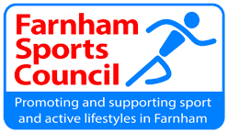 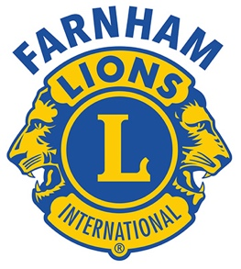

June 2023
Dear

You may well have seen in a recent Farnham Herald that the Farnham Sports Council have partnered with the Farnham Lions Club charity to help fund sporting projects within our community.

The Lions Club has given the Farnham Sports Council the chance for local sports clubs to receive from the volunteer, charity organisation financial and possibly personnel support.

The Lions already have a proven track record of helping our community, be it individuals or an organisation and plan to replicate this process and target assistance to our local sporting clubs.

What is this new partnership offering?

The plan is to help fund some smaller scale needs of clubs in the Farnham Sports Council area.

As a guide we are very comfortable with funds of around £350 per application, other projects can be looked at on their merits. PLEASE DO ASK!!! Sadly, we may struggle with new stadium or even a club house.

Any funding will be on a needs rather than a want basis but no running costs, such as fuel, wages or rental will be accepted.

As a rough guide, we are interested in supporting the following :

Funding coaching courses
Sponsorship of team or training kit
Sponsorship of equipment
Help individuals in finical need with subscriptions.

Farnham Lions may offer the applicant whole or part funding but also could entertain being part of a bigger funding package with other organisations if required.

How do you seek financial funding?

Please note that the attached notes should be read in conjunction with the “Application for Funding” document.

- By completing the “Application for Funding Document with full justification for the request on a needs basis and submitted to the Farnham Sports Council for ratification and support/or amendment.
- FSC endorse/amend the application and send it to Lions Sports Committee for full analysis and review. If approved, then approval to support the application would be sought from the Lions Club in the same manner as Community Support applications are determined at present.

- Agreed funding will be transferred by Farnham Lions to the successful individual sports club account.

Further copies of the “Application for Funding” document can be obtained from Sue Keogh at the Farnham Sports Council

What do Farnham Sports Council and Lions Club get out of it?

AWARENESS OF WHO WE ARE!!!

Something we can affix the Lion’s logo on such as kit or even a sign, helps us with publicity of the grant on yours and our own social media channels, with publicity in the Farnham Herald and even your help by coming to a fund raiser or even help to publicise an event.

We both look forward to a successful partnership.

Graeme Main- Incoming President , Farnham Lions
David Gill-Chairman, Farnham Sports Council.

