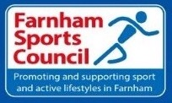

A Sport Development

Plan for the year 2024

Produced in four main sections:

[Preceded by a one page Summary of Actions for 2024 and our Aims and an Introduction]

A. The benefits of sport and physical activity for Farnham

B. The current scale of sport and physical activity in Farnham

C. The issues that affect the promotion and development of sport and physical activity for everyone in Farnham

D. What the Farnham Sports Council with the support of their partners will do [action plan]

Note - The audited accounts and the annual report of the Chairman are presented at each year’s AGM, and are available separately

Note – The Farnham Sports Council’s Sport Development Plan is updated annually to coincide with the Annual General Meeting and the new year

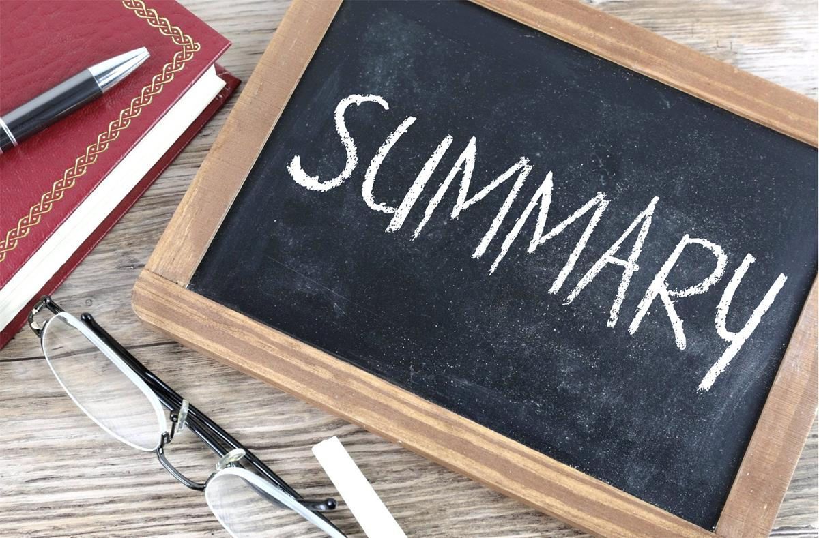

A one-page summary of actions for Farnham Sports Council in 2024 is as follows:

Engage with, and involve, more clubs

Promote wider participation in the annual Farnham Sports Awards

Actively support a limited number of community sports events

Highlight opportunities for talented young people

The desire to grow and develop disability sport

Improve partnership working and opportunities

Sport and climate change action – a 50th anniversary legacy initiative

Improve the visibility of the Farnham Sports Council

To actively encourage a greater variety of sports/clubs in Farnham

Maintain and monitor local grants, including the prospects offered by Farnham Lions

Maintain and organise the annual Club Conversations event

Provide advice and support to sports clubs with crucial needs in Farnham

The AIMS OF THE FARNHAM SPORTS COUNCIL

The Farnham Sports council advocates and promotes partnership working.

Our key partners, besides our local clubs, are Active Surrey, Waverley Borough Council, Farnham Town Council, the Surrey Playing Fields and the Farnham Herald. We value these working relationships. Farnham Sports Council meets termly plus hosts an AGM in November each year. It also establishes and provides ‘working groups’ for a number of its key activities [as outlined in section D].

At the Farnham Sports Council AGM in November 2015, the following aims were adopted:

To increase the number of people taking part in sport and physical activity in and around Farnham

To support the town’s valuable sports clubs to be sustainable and enjoy a higher profile

To act as the umbrella organisation and the voice for sports clubs and associations in the town

This is what we’re here for!

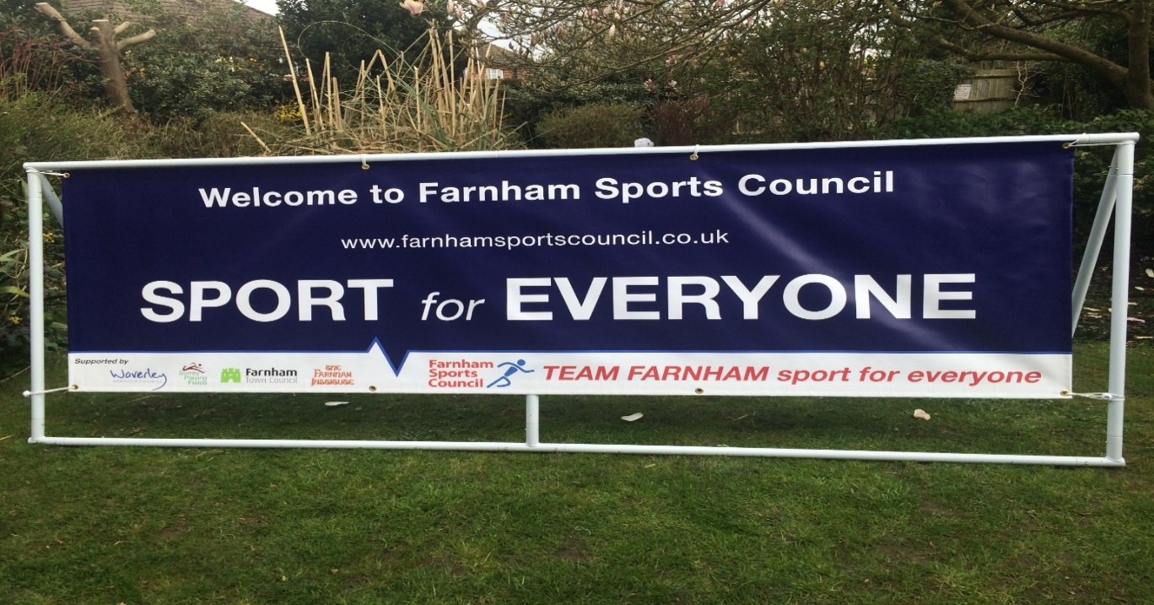

Introduction.

Welcome to Farnham Sports Council’s Sports Development Plan for the year 2024. The plan is updated annually or more frequently, especially the sections relating to the local emerging issues and action plan. In 2023 the sports council celebrated its 50th Anniversary with a special event held at the Frensham Pond Sailing Club and featured a countdown of 50 sporting highlights over the previous 50 years, something that was well-publicised by the Farnham Herald.
Sport and physical exercise is good for mind, body and spirit. Watching your hard work pay off and achieving your dreams or ambitions through sport or for health reasons or personal image brings about a feel-good factor and tons of self-confidence.
We have to be honest, sport isn’t for everyone, though physical activity and active lifestyles are crucial for healthy individuals and communities. More than a century ago, Oscar Wilde was once asked if he ever took part in physical recreation. He replied ‘whenever I feel the urge to take part in physical recreation, I lie down until the feeling goes away’. For some people in our town, ‘sport’ may not be ‘their thing’....... but for many it is, and Farnham Sports Council along with its key partners will do all that we reasonably can to ensure that a varied and high-quality sport and active recreation service, promoting and encouraging active lifestyles, is available to the community.
A famous American Footballer was once asked on a television show what he liked most about the game. He said, “do you know what my favourite part of the game is - the opportunity to play’. These days, we are ‘fed’ with more sport than ever. Television stations devote lots of time to covering the Premier League, the cricket, the rugby, the tennis...... Sky Sports, for example, covers just about every sport and sports event from around the world.......while there are countless ways to talk about or read about sport everywhere, including the growth of TNT Sports, streaming services and the internet. We can even ‘play’ sport on the PlayStation or the computer, taking the reins of, say, Manchester United on the virtual football field. E-sports are big business in Asia and North America – and now in the UK.
But all of it is, in the end, just a distraction from the real fun and benefit of actually playing sport or doing real exercise. Whether it is part of an organised team at the weekend, playing in the playground or park during lunch breaks at work or school, or even on your own, nothing beats the simple pleasure of it. It’s also a chance for us to compete, to bond with friends and family and to get some excitement and exercise. Sport matters in Farnham and it’s proven to be good for one’s physical and mental well-being.
We hope that the Farnham Sports Council 2024 plan will reflect the current sporting landscape and some of the issues we need to focus on in the coming year.
David Gill, Chair of Farnham Sports Council

Section A. The benefits of sport and physical activity for Farnham
1. Historically, through organisations such as Sport England and Active Surrey, the emphasis on community sport has very much been on sport for sport's sake [there was something which highlighted that, known as the sports development pyramid]. Since then, the political agendas have increasingly emphasised the health and physical activity elements of providing sport, particularly with a creaking NHS and an ageing population. Nowadays or wherever the agendas shift, it’s crucial that we all work together in partnership to maximise resources and opportunities. Our key allies and partners are Active Surrey, Waverley Borough Council, Farnham Town Council and all the community sports clubs in the town. The nationwide network of County Sports Partnerships – of which Active Surrey is one – have changed their identity with a new brand: Active Partnerships.
2. New strategies and priorities emanating from Government, Sport England [the latest is called Uniting the Movement] and sports and public agencies such as Active Surrey and Waverley Borough Council emphasise the strong and emerging priorities for promoting health and 'physical activity' but there are other priorities, too, in Farnham which largely fall outside the pure health and physical activity agenda.
3. If we asked all those sport clubs what they could relate to - sport and/or physical activity - I think that virtually all of them would say that their rationale is 'sport', or in some cases healthy lifestyles. We say this because - at a time when we are trying hard to encourage and motivate the ‘non’ or less active in our communities - our best ambassadors to make the case for sport and active lifestyles will be family and friends, specifically those who already benefit from such activities. The 'sport' element of what we're trying to achieve and promote, for all ages, is key. It’s well organised in our town and it gives it a vibrancy. Similarly, if Farnham [as we do] promote, encourage and support 'elite and high performance' sport, then those who succeed – names from Farnham include racing driver, Mike Hawthorn, cricketer Graham Thorpe, rugby player Jonny Wilkinson, Paralympian Rachel Morris and amateur sailor Nick Craig - are our standard-bearers and role models.
4. Local authorities and other key public organisations in the area are of course concerned with improving the health of their communities, but they will [or ought to] be just as concerned about the wider 'quality of life' matters for the residents of Farnham. Politically, we don't think you'll find many Farnham councillors within the county, borough and town councils - and educational and public bodies - who don't place a very high emphasis on 'sport' and the broader value – such as the inclusivity and social cohesion - in their local communities.
5. Whilst Farnham is a relatively wealthy area to live and work, there is crime and there are areas in the town of relative deprivation. Tackling social exclusion - through the message and action of sport, the language many people understand, might be a priority for Farnham Sports Council in terms of supporting the development and outreach work provided by local authorities and other agencies. In the current world climate, where exclusion, racial and religious tensions sometimes exist, potentially even locally, 'sport’ is a language understood by everyone and is still often the 'breakthrough' mechanism to help our nation – and specifically our own town. In other words, sport has the power to make a difference to bond and create more socially cohesive communities.
6. Community Safety is also vitally important to local communities. Sport [specifically] can reduce the chances of young people slipping into lives of crime. There is a reduced risk of a person offending or re-offending if they can be encouraged to participate in sport. Ask many of the town's residents and they will tell you that crime, and the fear of crime, is a top issue for them. Sport, specifically, with the help of community sports clubs and community outreach work, can make a difference to supporting those lives. People at the wrong end of crime really do want the voluntary sector and public agencies to do, or be seen trying to do or provide, something to help them on their own terms.
7. For disabled people - many of whom we don’t reach, and who do feel excluded from sport in their community - you are more likely to reach them, not just through the physical activity message, but crucially through the fun, well organised and social element of sport – and especially a warm welcome. It can make a huge difference to their lives but the medium by which you try to achieve it is crucial. We don’t want the London 2012, the Rio 2016 and the Tokyo Games [held in 2021] Paralympic Games to be a wasted opportunity. It’s crucial that all sections of the community in Farnham feel that sport is inclusive and that clubs and sporting [and health] centres are welcoming environments. In fact, sport is, and should be, for everyone.
8. Environmental issues are also important. Parks and public open spaces – areas we are proud to have for leisure use - and sport fields provide focal points and green 'lungs' for the town, while new and high-quality facilities can inspire more people to take part in sport [eg. Farnham Rugby Club, David Lloyd Club]. In the countryside around Farnham, and there's much of it, sports such as canoeing, rambling, cycling, sailing, contribute to healthy lives and the sustainability of the rural economy. Environmentally, the government's Housing agenda and targets must be monitored carefully - it provides both opportunities and threats to places where sport is played, both informal and formal. We need to safeguard recreational open spaces and playing fields for future generations.
9. Children need to learn lessons that will stand them in good stead for the rest of their lives - a process in which sport can play a valuable role. It teaches people not just the health benefits, but the benefits of rules, self-discipline, team work, mutual respect and fair play. It enables youngsters, in particular, to channel their energy, competitiveness and aggression in a personally and socially beneficial way. Reflecting the COVID-19 pandemic period, sport has so much to offer and help young people. Schools, of course, have a vital role to play but the value of all of our precious community sports clubs in this respect cannot be understated.
10. Urban Connection and Regeneration, for example, providing and improving sports facilities and hosting sporting events can enhance the town’s image and improve local self-esteem. Such benefits are often intangible, but their knock-on effects can be truly substantial. Examples are numerous in our town – they include key sports club events and local running and cycling events. For runners a range of significant events take place locally throughout the year and the annual Farnham Pilgrim marathon and half marathon events in September are highly respected. Similarly, for cycling in the community, the annual Charity Bike Ride and the Festival of Cycling are well organised events.
11. The Value of Volunteers - voluntary activity is a key element in creating and sustaining an active and inclusive society, and community sport is one of the main ways in which people choose to do something with friends or family members - we regard this as a very important feature in today's society - and/or put something back into their communities. The previous strategy – and latest one from Sport England [Uniting the Movement] - continues to place a high emphasis on the value of volunteering, both to the volunteer and to the sports club or organisation they want to help.
In conclusion, SPORT and physical activity is important to everyone in the town. Thousands of people in Farnham benefit directly through regular active participation and, for thousands more, the benefits are less direct but no less important. Sport matters in Farnham.

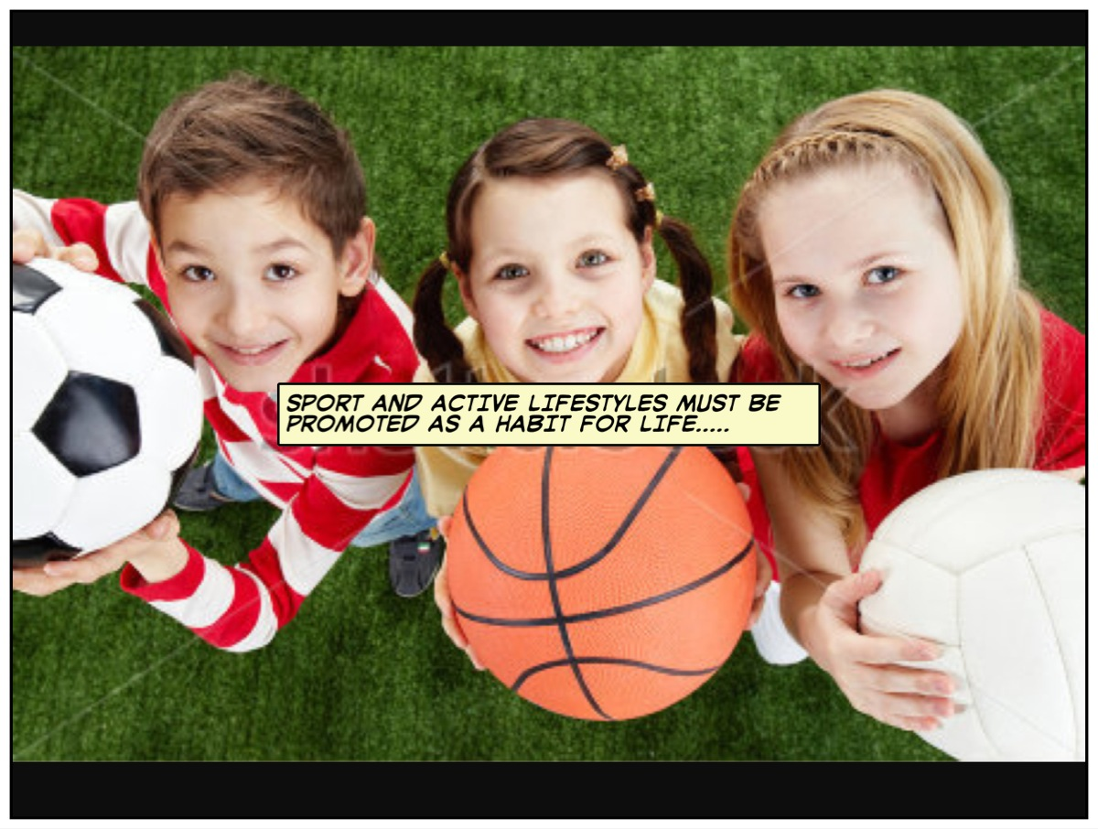

Section B. The current scale of sport and physical activity in Farnham [an overview]
This section – in no particular order - is designed to give a scale and a flavour of the current sport and physical activity provision in the Farnham area:
Recreation Grounds in Farnham
The town’s jewel in the crown is Farnham Park which provides a range of sport and recreation amenities but most of the public recreation grounds are located on the periphery of Farnham – for example, in the villages at Wrecclesham, Rowledge, The Bourne, Hale, Heath End, Weybourne and Badshot Lea. Some of the facilities, especially pavilions, on public recreation grounds need modernisation and many of these facilities have been identified in the [2017 and 2020] Farnham Neighbourhood Plans and were submitted to the [2018] Waverley Playing Pitch Strategy.
Cycling
Especially since the London 2012 Olympic Cycling events were held in Surrey, Farnham and the surrounding areas offer new and serious cyclists – young and old of all abilities - casual or club opportunities. Cycles and equipment are sold at Halfords and a specialist shop at Hoops Velo. Farnham Road Cycling Club and VC Meudon are amongst the active cycling clubs in the area. Local events include the Farnham Charity Bike Ride and a Cycling Fair.

Rugby
Farnham Rugby Club is a genuine community club with state-of-the-art facilities and plenty of teams to accommodate all ages and abilities – including a huge number of youngsters in the youth and minis sections. Past players include Jonny Wilkinson and Peter Richards who both played for the winning English World Cup team in 2003. The club require more playing space to accommodate the demand especially from youngers players, including the need on the current site for an artificial playing surface.

Golf
The Farnham countryside is ideal for golf, the nearest course to the town centre is the Farnham Park Golf Course located in Farnham Park. It’s a par 3, nine-hole course, which is ideal for those now less active, or beginners or those with limited time. The Farnham Golf Club was founded in 1896 and is located on the outskirts of the town in The Sands. Other golf clubs in the area include Hankley Common Golf Club, with its British Open qualifying course.

Running and Walking
The surrounding forest, heath and common landscape is perfect for casual running. There is an active local running club, Farnham Runners – and a separate town running club - who welcome all ages [16 years +] and fitness abilities and the Farnham Runners support the regular Alice Holt Forest parkruns. Amongst various local events, the Weyside Rotary organise the hugely successful Farnham Pilgrim Marathon and Half Marathon each September. The local landscape is ideal for Ramblers and Walkers, too. A number of private and commercial fitness and ‘commando’ type operators provide their services in and around Farnham

Football
Founded in 1906, the Farnham Town Football Club [they aspire to upgrade their ground facilities] has been the senior football club in the town until recently. Badshot Lea Football Club was initially formed in 1907 and now competes at a similar level and the club finally moved into a new and needed ground of their own - at the former rugby club site - from 2019/20 season. Both clubs have to meet the requirements of the FA’s ground grading regulations. The clubs also run youth sections and there are numerous other senior and youth football clubs in the area – and walking football at Weydon School

Cricket
Farnham Cricket Club is the oldest established club in Farnham and one of the oldest clubs in the country. Founded in 1782, the club maintains its main site adjacent to the castle in Farnham. One of the largest and most successful clubs is Rowledge Cricket Club on the southern outskirts of the town. There are numerous other important cricket clubs in and around the town, many of whom also operate youth cricket sections, including the Bourne who are due to fully replace their pavilion facility [benefiting the local clubs of football, cricket and running] thus improving the facilities for sport locally. Tilford Cricket Club has shown significant growth in participation in recent years including the introduction of a successful All Stars programme.
Angling
Farnham has a wide diversity of fisheries to cater for the needs of the local anglers. Founded in 1906, Farnham Angling Society is one of the oldest and most successful angling societies in England and members enjoy fishing in over 32 ponds, lakes and stretches of river including Badshot Lea Ponds, Frensham Great and Little Pond and the River Wey. With well over 3000 active members, it has the largest membership of all the clubs in Farnham.
Sailing
The Frensham Pond Sailing Club has produced many top sailors and the sport of sailing is available for all ages and abilities on the beautiful Frensham Great Pond. They also have an outstanding Sailability section for disabled sailors.

Farnham Leisure Centre.
The town’s community sport and leisure facility, run by Everyone Active on behalf of Waverley Borough Council, offers community access to almost every sport and the complex facilitates swimming pools, sports hall, squash courts, dance, fitness and exercise rooms, and more. The centre provides swimming lessons and coaching in other sports and hosts the well-established Farnham Swimming Club. The Farnham Disabled Swimming Club [Swimability] is also based at the Leisure Centre as is the Farnham Senior Sports Club [aimed at those aged over 50].

Private Health Clubs
In addition to the gym provided at Farnham leisure centre, the David Lloyd Club and the Nuffield Health Clubs offer modern and high quality facilities for sport, health and fitness activities. There’s also an Anytime Gym in the town centre.
There is also an abundance of private operators providing opportunities for aerobics, dance, yoga, keep fit, weightwatchers and other related activities
School based facilities
Local Secondary Schools offer some of their facilities for club and community use, such as the all-weather pitch at Heath End and the Sports Hall at All Hallows. However, Weydon School has a significant range and quality of sports facilities, including two outdoor, artificial pitches, which they make available to the local community. The University of Creative Arts have very limited sport facilities and tend to hire facilities. Local primary schools have limited sports facilities with the exception of Waverley Abbey School in Tilford which has extensive outdoor recreational green space
The Bourne Club
One of Farnham’s most established and popular ‘member’ sports clubs provide excellent tennis facilities as well as squash, badminton and other recreational activities. Some of their facilities have recently been upgraded.
Badminton
Besides the leisure centre and the Bourne club, there are numerous badminton locations in the area, mostly small in size and often located in village and community halls around Farnham.
Athletics
The Aldershot and Farnham Athletics Club are based at the Army’s Military Stadium, a short journey away from Farnham. Over the years, they have produced numerous national and international athletes. The facility is Army-owned and it is managed by their appointed contractors [so the club have little control] and the venue is located in the adjacent borough of Rushmoor but it is a vital athletics facility for residents of Farnham.
Archery
The Farnham Archers are located on the outskirts of Farnham. At the inaugural Farnham Community Games in 2012, the Farnham Archers were easily the most popular activity – they enjoyed the longest queue for the public ‘to have a go’! They recognise that because of their isolated location they need to become a more visible activity.
Tennis
Tennis is one of the most popular sports in the Farnham area with some excellent facilities at the Bourne Club and the David Lloyd club as well some excellent community tennis clubs operating locally including Brightwell, and on the recreation grounds at Wrecclesham, Bourne and Badshot Lea.

Netball.
The Waverley Netball Club play at Farnham Leisure Centre and netball is a popular school activity, though not many clubs operate in the immediate area, though a club for walking netball has been established in Farnham. The Wavell School in Aldershot is the regional centre for netball.
Judo and Martial Arts.
A number of martial arts clubs [eg. Karate, Tae Kwon Do, Judo] operate in the area, particularly at the Farnham Leisure Centre. Some of the instructors – and members - of these clubs have achieved national and world titles.
Basketball.
Most of the higher-level basketball activity in the area takes place at Guildford and other larger adjacent towns. The sport of basketball once had an active club for all ages at the Leisure Centre and this activity ideally needs to be re-established in Farnham..
Hockey.
The Aldershot and Farnham Hockey Club, based at Heath End School on their artificial pitch, are one of the most successful clubs in the region, offering a large number of playing and training opportunities for men, women and youth. The club have been keen to secure their own dedicated hockey facilities, to meet their high playing standards and growing membership needs, with their own adjacent clubhouse – it’s a sports council priority.
Bowls.
Another popular sport in the area, Bowls venues are located at Farnham [Bear Lane] and in the surrounding villages. The Farnham Bowling Club have a significant issue relating to car parking limitations and they have been in discussion with Waverley over re-location options in the area.
Horse riding.
There are a number of private stables offering horse and pony riding, including disabled provision for carriage driving and through the Riding for the Disabled Association.
Gymnastics.
Clubs for the community operate at the Farnham Leisure Centre and the ever-growing Stellar Gymnastic Club now based at Heath End School. The ‘focus’ club in the region, however, is the Rushmoor Gymnastics Club which is located nearby in Aldershot.
American Football.
The Farnham Knights American Football Club is based at the Farnham Rugby Club, providing for both senior and juniors players. They are one of the more ambitious and successful American Football Clubs in England.
Boxing
The Atomic Boxing Club have made a positive contribution to the local community during their short existence in Farnham but they continue to seek a venue and funds for a permanent boxing location in the town.
Roller Hockey
The successful Farnham Roller Hockey Club have produced some England internationals over the years. They started their life at the Farnham Maltings but now operate from the Farnham Leisure Centre.
Boccia
The Farnham Boccia Club began its life in 2016 as a Farnham Sports Council initiative and it has grown and developed from its David Lloyd Club base. Boccia is especially popular for those with disabilities and it is a Paralympic Games sport.
Skating and skateboarding
Adjacent to Farnham Leisure Centre, there are some excellent ramps and other facilities for the various types of skating, skateboarding and cycling
Pickleball
A growing sport, Pickleball, has arrived in Farnham and The Aldershot and Farnham Pickleball Club are based at the Heath End School but there are also at satellite centres around the town
Powerchair Football
A Farnham club was founded in 2022 and players use specially designed powered wheelchairs to take part in this fast and exciting sport. The club train at Heath End School.
Floorball
Triathlon
Triathlon comprises swimming, cycling and running. The Farnham Triathlon Club are based at the Farnham Leisure Centre and they have produced many successful triathletes over the years
Other sports available locally but outside the Farnham area
There is also a Farnham Floorball Club which did shut down for a while but is back training and competing successfully.
There is a wide range of other sports available locally or reasonably close by, mainly within a short driving or travelling time, especially in the Aldershot or Guildford areas. Among them, pistol and rifle shooting, rowing, canoeing/kayaking, orienteering, carriage driving, ice skating and ice hockey, fencing, croquet – in fact, there is local ambition and momentum to start a croquet club in Farnham - sub-aqua, trampoline, table tennis, volleyball, climbing, water polo and skiing/snowboarding on artificial slopes.

Section C. The issues that affect the promotion and development of sport and physical activity for everyone in Farnham

The issues have been identified through the local knowledge of the Sports Council and from guidance from local sports clubs and key partner organisations:
1. The following sports clubs do or might well have 'significant needs' to meet the demand for more playing/water space and/or new provision or major improvements to their ageing facilities during the timeframe of the Farnham Local Neighbourhood Plan and, crucially, they have informed Waverley Borough Council’s most recent Leisure Facility Strategy [2017] and Playing Pitch Strategy [2018].
- Frensham Pond Sailing Club/Sailability
- Farnham Swimming Club
- Farnham Bowls Club
- Rowledge Cricket Club
- Farnham Cricket Club
- Farnham Rugby Club
- Farnham Town Football Club
- Farnham United [youth] Football Club
- Badshot Lea Football Club
- Badshot Lea Cricket Club
- Aldershot & Farnham Hockey Club
- Atomic Boxing Club

2. There are some pavilions on public recreation grounds in and around the town which will require replacement or modernisation during the life of the Plan. These include the recreation grounds at Wrecclesham, Rowledge, The Bourne [the highest priority], Weybourne, Hale, Heath End, Badshot Lea, Farnham Park and some of the outlying villages. A site for a Farnham-based croquet club is also being sought.

3. Disability sport in Farnham is reasonably well catered for but mainly with activities such as cricket, boccia, swimming and sailing. However, more emphasis will need be to be placed on sporting opportunities and provision to meet the needs and wants of disabled sports enthusiasts of all ages and abilities. The umbrella group, formerly the Farnham and District Sports Association for the Disabled, are called ‘Farnham Swimability’ because of their swimming activity emphasis. The Annual Club Conversations event in 2018 revolved around disability sport awareness. National surveys on disability sport inform us that ‘inclusivity’ and the welcoming aspect of joining clubs is a key element to increasing participation.
4.The town has some excellent and modern private health club facilities and, in a changing world, the health and fitness agenda will become more critical during the years to come. There are some good running and walking routes in close proximity or within a short journey time for most residents. Cycling in the area, however, needs better and safer routes/places to encourage more cycling participation by individuals and families.

5. The Farnham Leisure Centre plays an important part in the provision of community sport and fitness, especially in respect of community access and affordability and because there are 'pay and play' opportunities. However, the opportunities are limited because demand exceeds supply during peak times, especially for the swimming pools and the sports hall. Some large clubs, therefore, such as the Farnham Swimming Club, need more swimming space to accommodate club training and events. An extensive refurbishment of the centre was due to take place in 2019/2020 but it stalled – and we await news on progress.

6. A number of clubs are looking for permanent homes, such as the Atomic Boxing Club and The Farnham School of Tae Kwon Do and this situation will fluctuate on an on-going basis. More options to accommodate current or emerging sports clubs and activities need to be identified, including better access to community halls and school's facilities. Some schools in Farnham have excellent sports facilities both for the general public to hire and for linking sports development opportunities with local sports clubs. The Farnham Floorball club folded during the pandemic but re-started in 2021. The progressive Stellar Gymnastics recently secured a more permanent venue for its activities at Heath End School.

7. There are a number of very good 'membership' sports clubs in the Farnham area covering sports such as tennis, golf and bowls and these clubs have varying levels of cost but are generally open to everyone to join.
The Farnham Bowling Club’s membership levels have dwindled, largely due to lack of car parking in the vicinity of the club. There is, however, demand for more 'easy access' or 'pay and play' sports opportunities in Farnham. The Bourne club is one of the longest-established clubs in the area and seeks to continually modernise to maintain its membership base especially with the range of alternative health and tennis clubs now available. The David Lloyd Club and the Nuffield Health Club amenities both provide excellent facilities and services.

8. The quality of sports and recreation facilities - both indoor and outdoor - and the level of support services [administration, coaching and volunteers] will be crucial in order to compete for people's leisure-time and organisations such as the local authorities and sport’s governing bodies will have a continuing key role to play in supporting the valuable community sports clubs in the town. Securing sufficient volunteers to help out is a key issue for some clubs.

9. The marketing of sports opportunities in the town will be crucial to encouraging and making all the community aware of sports and recreation opportunities and this will largely fall to individual sports and health clubs to raise their own profiles. However, the local authorities, the governing bodies of sport and the Farnham Sports Council all have a promotional and coordinating role to play to ensure that all sections of the Farnham community are included, welcomed and encouraged to participate in sport and active lifestyles. One of the challenges for sport in Farnham is keeping up to date contact details for sports clubs but we are on the case. Some information was to be found on websites relating to Waverley BC, Farnham TC, Active Surrey and the Sports Council but all organisations find it hard to track the correct, up to date contact information – some form of ‘sharing’ of information between bodies might be useful in future. The sports council’s upgraded website has represented an opportunity to better coordinate club contact information.

10. Regular survey and research work has been undertaken by Farnham Sports Council, for example local sports clubs were invited to identify the key issues and priorities in Farnham in 2015, 2022 and 2022 [a SWOT survey] as part of better local understanding of sport in the area. And at the AGM’s at the end of 2015, 2016, 2017, 2018, 2021, 2022 ‘Club Conversation’ events – held in conjunction with Active Surrey and Waverley Borough Council, and held at Farnham Rugby Club - reacted to the key needs of clubs by organising seminars on relevant topics. The 2021 event centre around Sport and Climate change and the 2022 event revolved around Dementia and Mental Health issues in respect of sport. In November, 2023, the event celebrated 50 years of the Farnham Sports Council and highlighted so many fine achievements.
Farnham Sports Council piloted ‘Club Conversations’ for Active Surrey in 2015 and they are the only local sports councils in the county to still be organising such events for their local clubs. It is important that the Farnham Sports Council keeps in tune with the key issues facing local sports clubs in a fast-changing world and, to this end, club surveys are carried out every few years to maintain contact and ascertain intelligent data. The Survey Monkey in 2022 was instigated to assess the challenges clubs were facing since the coronavirus. The surveys have to be meaningful and relevant

11. Because of the coronavirus pandemic, 2019-21 was the most challenging period for Farnham Sports Council since it was established in 1973. Similarly, it goes without saying that it was been an incredibly difficult time for all our sports clubs, the community leisure centre and local health clubs. Many clubs – and the leisure centre and health clubs - had long periods of closure in what had been an unprecedented period. We would like to congratulate so many of our local community facilities – and their excellent volunteers - for being so committed and resilient. The sustainability of all of our precious sports and healthy living amenities was always going to be paramount during such a seismic event. In the main, we’ve come through it and our clubs and leisure facilities have truly bounced back.

12. Although the ’50 sporting highlights in Farnham over the past 50 years’ was an important celebration of local sport, Farnham Sports Council would like to leave behind a 50th anniversary legacy initiative, it is to develop a sports sustainability project in 2024. Several key partners have been identified including Farnham Town Council, the Farnham Lions and the UCA

Section D. What the Farnham Sports Council with the support of their partners will do [action plan]

The feedback from clubs and sports council meetings – and our work with key partners - has helped to identify the main priorities in 2024 for Farnham Sports Council. The following activities have been identified as the key priority work areas for the coming year;

Introduction
Farnham is blessed with a wide variety of sports choices, and virtually every main sport is well catered for and available to the local community, thanks to the quality of the sports clubs in Farnham and to the volunteers who run them. As a local sports council, we review the variety of active and sporting opportunities on offer to our community and, in recent years, we’ve helped a number of local clubs with issues or problem-solving. It goes without saying that the town’s sports volunteers are the lifeblood of community sport and their goodwill helps to enrich the quality of life for all of the town’s residents. Encouraging and promoting healthy and active lifestyles in our local community will continue to become more and more a feature of the community agenda for us and our key partners……

1. Engage with, and involve, more clubs
The Farnham Sports Council has been operating for 50 years and the organisation previously encouraged a representative from different sports to sit on the sports council. However, a key aim for 2024 is for the current sports council to engage with as many local sports clubs in the Farnham area and make them part of the sports council’s work and communications.
At the same time, the sports council are conscious of supporting a range of external strategies emanating from the Government, Sport England [a new 10-year strategy was launched in 2021], Active Surrey, Waverley Borough Council and others. Locally, these include the Farnham Neighbourhood Plan [2020] and a Facilities strategy [2017] and Playing Pitch Strategy [2018] from Waverley Borough Council, some of which are due to be updated in 2024.
Farnham Sports Council attends many ‘partnerships’ events and it organises a minimum of three meetings each year, plus an Annual General Meeting, as well as numerous informal Executive meetings.

2. Promote wider participation in the annual Farnham Sports Awards
The annual Farnham Sports Awards are a regular and well-established feature of the town’s activities and, incidentally, in the pandemic year [2020] Farnham was the only local sports council in Surrey to operate an awards scheme, achieved virtually.
Historically, the annual event has been promoted and administered in conjunction with Active Surrey, but Active Surrey reviewed their working priorities in 2019 and have withdrawn from the partnership arrangement with all local sports councils in Surrey. The action plan for the sports council is to actively encourage wider and greater participation in the local award’s scheme whilst also lobbying for a high-profile county event - particularly to recognise and value our committed volunteers and sports clubs on a bigger stage. One positive for the sports awards in the last two years has been the support the sports council received from the Farnham Herald and this promotional benefit is expected to continue.

3. Actively support a limited number of worthwhile community events
Community events which promote sport and active lifestyles are relevant to the aims of the sports council, and 2024 will continue to see a review and re-assessment by the sports council of what types of events - directly run or in partnership with others – will work well for Farnham to promote sport and active lifestyles. The Leisure Centre Open Day, and Sport Relief and similar initiatives, in partnership with Everyone Active [who run the leisure centre on behalf of Waverley] is an ideal opportunity to grow and broaden participation in active lifestyles. The sports council will also actively support the Woodland Woggle and also the Farnham Pilgrim Marathon, which attracts hundreds of runners, and has achieved national recognition for its organisation and the scenic route through the Surrey Hills. The sports council also needs to be aware of, and support, the wider range of community sports and active lifestyle events that happen in Farnham.

4. Highlight opportunities for talented young sports people
The sports council will continue to support talented young sports people. There is a contractual requirement for the David Lloyd club to offer 15 memberships of their club to talented athletes and sports stars in Farnham, to support and help with their training needs in a high quality and prestigious location. The membership scheme is owned by Waverley Borough Council and the sports council aim to work in partnership with the council, offering support and advice on who should benefit locally. Active Surrey and Waverley Borough Council operate schemes for talented young sports people to use local sports and leisure facilities. Through the David Lloyd scheme and other means available, Farnham Sports Council is committed to raising the profile of, and actively supporting, our star athletes and, despite limited financial resources, the sports council are sometimes able to give small training or much needed equipment grants to worthy young individuals. Furthermore, given our connections to Surrey Playing Fields, and others, we are able to signpost clubs and individuals to grants and bursaries.
Farnham Sports Council also needs to more widely promote the Free Access for County Sportspeople [FANS] scheme in conjunction with Waverley Borough Council and Active Surrey. This initiative allows talented young sports people at county level to have free access to training facilities at Farnham Leisure Centre and other leisure centres in the borough of Waverley.

5. The desire to grow and develop Disability Sport
There is still much work to do in relation to making sport more inclusive for the wider community and we shall strive to make more sport, more accessible, to more people. Despite the recent challenging years, some clubs have responded by positively looking at ways and means to make their club more inclusive. Disability sport is especially important and we must in 2024 give special support to clubs and groups who organise sporting opportunities for those people with disabilities or are disadvantaged or have special needs because sport is for everyone. The most recently introduced sport to Farnham was cricket [at Rowledge].

6. Improve partnership working and opportunities
The Farnham Sports Council actively promotes partnership working, and crucial to its effectiveness are Waverley Borough Council, the Farnham Town Council, Active Surrey, the Surrey Playing Fields, the Farnham Lions and the Farnham Herald. Partnership working to create better networks, awareness and opportunities for the benefit of sport in Farnham will be maintained and, where possible, improved. Our key aspiration for 2024 will be to examine further partners to promote our aims. So, the key action for the coming year will be to engage the charitable organisations that run ‘sport and physical activity’ events and ALL local sports clubs into the ‘Farnham Sports Council family’ thus increasing the range of key partners we work with. We are planning to liaise with the Farnham Health Centre to look at ways to work in partnership to promote more active and healthier lifestyle initiatives and ‘referrals’, particularly focusing on community mental health.
The sports council will continue to support and monitor the important work of the Farnham Neighbourhood Plan and the Farnham Infrastructure Plan, and any opportunities for sport through the Community Infrastructure Levy [CIL].

7. Sport and Climate Change action
In 2021 the sports council hosted a special event for clubs and other organisation on Environmental Sustainability. The key outcomes were that clubs ought to have a Sustainability representative on their committees and b] clubs should aim to produce action plans especially giving consideration to transport issues and car-sharing. The sports council will continue to promote the importance – and raise the profile - of Sport and Climate Change [Sustainability].
A key aim for 2024 is to develop an environmental sustainability project alongside the Town Council, the Farnham Lions and the UCA [through Professor Martin Charter]

8. Improve the visibility of the Farnham Sports Council
An action for 2024 is to produce some form of promotional video to showcase the sports council and local sporting opportunities. A sporting video ‘Farnham’s Sporting Greats’ was completed in January, 2019 and placed on the website, and on YouTube, to let the community know more about our local sporting heroes. In late 2023, the Farnham Herald produced an unprecedented set of features on ’50 sporting highlights on Farnham over the past 50 years’. The articles submitted regularly by the sports council and many sports clubs in the community to the newspaper offers the chance to profile local club’s results, work and activities and helps to maintain and showcase the power of sport and the benefits of an active lifestyle. Social media – promoting events such as the sports awards – has been under-used and it’s something to have a plan for.

9. To actively encourage a greater variety of sports/clubs in Farnham
Whilst Farnham offers a wide range of sporting opportunities to its community, there are some additional sports that would give ‘added value’. For example, there is no recognised clubs for volleyball, trampoline, stoolball, lacrosse, basketball in Farnham – though some of these sports have expressed an interest [but finding the host facilities isn’t always easy]. In 2024 we will continue to engage and help/advise new and different sports to promote their sport or activity in the area. The Farnham Sports Council has a good track record of setting up new clubs in the area, or helping existing ones.
One new sporting opportunity that did come to the fore during 2023 was croquet and the sports council will be pleased to support any worthwhile proposals to introduce this activity to Farnham in 2024. And a key action for 2024 is to support any new development sports schemes at Weydon School and Heath End School. Both schemes offer ‘Dual-Use’ potential, in other words for both the school and the community to benefit in both cases.
Also, the sports council will support the Bourne Pavilion project - given the age and condition of the current facility and the number of local community clubs for cricket, football and running that will benefit.

10. Maintain and monitor local grants, including the prospects offered by the Farnham Lions
The sports council cannot operate without some funding assistance yet the funding support picture is changing. Waverley Borough Council have historically been our primary funders but they have had to review their funding priorities and there may not be any monetary support, at least for the foreseeable future. We can apply to Farnham Town Council for occasional funding support for specific projects. In 2023 the Farnham Lions came forward to offer funding assistance, not only directly to the sports council but also grants available to sport locally. This has been a significant opportunity and the sports council is grateful to the Farnham Lions for supporting our work. In 2024, in conjunction with their representative[s] we need to monitor the areas of best value for awarding grants secured from the Lions.

11. Maintain and organise the annual Club Conversations workshop
Farnham Sports Council led the way amongst all local sports councils in Surrey and Sussex [after a joint county’s bid by Active Surrey and Active Sussex for all local sports councils in those counties to initiate a networking event] by hosting the very first Club Conversations event in 2015. Farnham also, uniquely, have kept their event going each year [except for the pandemic year of 2020].
The proposal for the 2024 AGM is to host another Club Conversations event. This year’s theme is planned to be a celebration of television’s ‘It’s A Knockout’ and ‘Je Sans Frontiere’ events which Farnham took part in during 1974 – but we remain open to other meaningful debates on current sporting issues.

12. Provide advice and support to sports clubs with crucial needs in Farnham.
Many clubs don’t fully appreciate where grants or funding support might be available to modernise, grow or enhance their facilities. There are a number of key clubs who have new or upgraded facility needs, and the sports council can either offer this support or signpost clubs to the right places. Community clubs with significant facility needs at present include the Aldershot and Farnham Hockey Club, the Bourne Pavilion scheme and the Farnham Cricket Club and we should recognise that these three schemes have a high priority for sport in Farnham. However, to meet their membership needs some other significant clubs require enhanced facilities including Farnham Rugby Club – more space and /or an all-weather playing surface - and Farnham Town [youth] Football Club. All these latter sports – and the hockey club - are in the Monkton Lane corridor and each of them is also identified as important priorities for facility enhancement needs.
- ENDS -

